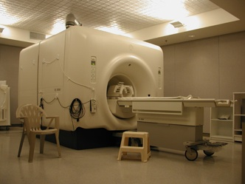  Are you eligible?  - Do you have a new diagnosis of breast cancer (stages I-IIIA)?  - Have not yet undergone treatment, including surgery?  - Are you between the ages 35-68?  - Are free from any metallic implants or biomedical devices?  If you answered YES, you may be eligible to participate in this study. | Contact Us  If you would like more information, or wish to enroll in this study, please contact us:  Email: cancerwellness@vcuhealth.org  Phone (804) 628-8869  For general information about participant’s rights, contact:  (804) 827-2157 | Cancer survivorship Research Team  - Virginia Commonwealth University
Did you know?  Some women have difficulty with certain cognitive functions following breast cancer treatments including struggles with memory attention, processing speed, multitasking and problem solving.  What is the study purpose?  Our goal is to better understand these difficulties in order to predict which patients are most at risk for experiencing them later on.  If you would like to participate, please contact our study team:  Email:  cancerwellness@vcuhealth.org  Phone: (804) 628-8869 | What will I have to do if I participate?  - 2 study visits, approximately 12-15 months apart.  Each study visit will include:  - Cognitive testing and questionnaires  - Brain MRI scan | 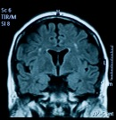  Benefits  You will not receive any specific benefits from participating.  Other  Compensation available after completion of each study visit.

